**BLG222E**

**Computer Organization**

**Project 2**

**Group Number: 37**

**Group Members:**

**1** - 150150729 Elif Nur Hasgül ([hasgule15@itu.edu.tr](javascript:void(window.open('/imp/dynamic.php?page=compose&to=hasgule15%40itu.edu.tr&popup=1','','width=820,height=610,status=1,scrollbars=yes,resizable=yes'))))

**2** - 150140055 İsmail Salih Namdar ([namdari@itu.edu.tr](javascript:void(window.open('/imp/dynamic.php?page=compose&to=namdari%40itu.edu.tr&popup=1','','width=820,height=610,status=1,scrollbars=yes,resizable=yes'))))

**3** - 150150151 İsmet Ata Yardımcı ([yardimci15@itu.edu.tr](javascript:void(window.open('/imp/dynamic.php?page=compose&to=yardimci15%40itu.edu.tr&popup=1','','width=820,height=610,status=1,scrollbars=yes,resizable=yes'))))

**4** - 150140032 Kadir Emre Oto ([otok@itu.edu.tr](javascript:void(window.open('/imp/dynamic.php?page=compose&to=otok%40itu.edu.tr&popup=1','','width=820,height=610,status=1,scrollbars=yes,resizable=yes'))))

**1 INTRODUCTION**

We designed a 8-bit input and 8-bit output Arithmetic Logic Unit which performs some arithmetic, logic and shifting operations with a register in this project according to the Figure 1.

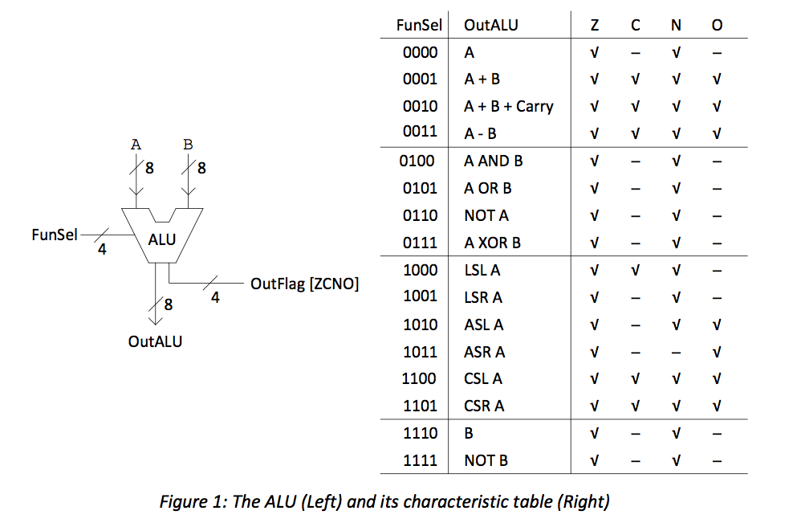

Then we designed an ALU System implementation according to this table.

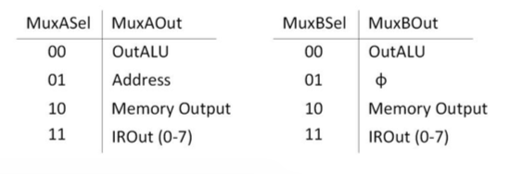

**2 CONCLUSION**

Those are our final circuits.

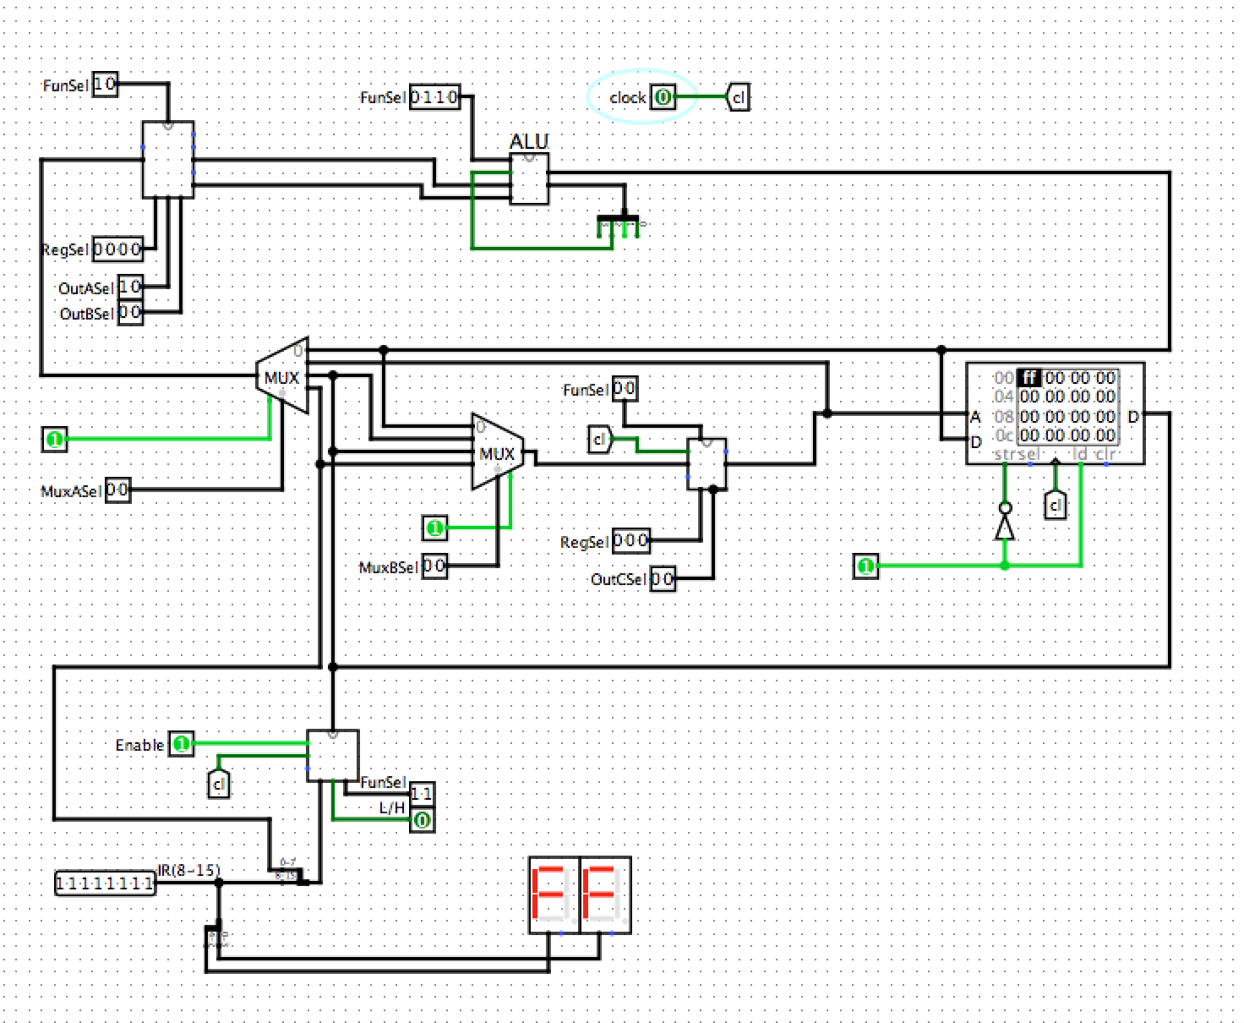

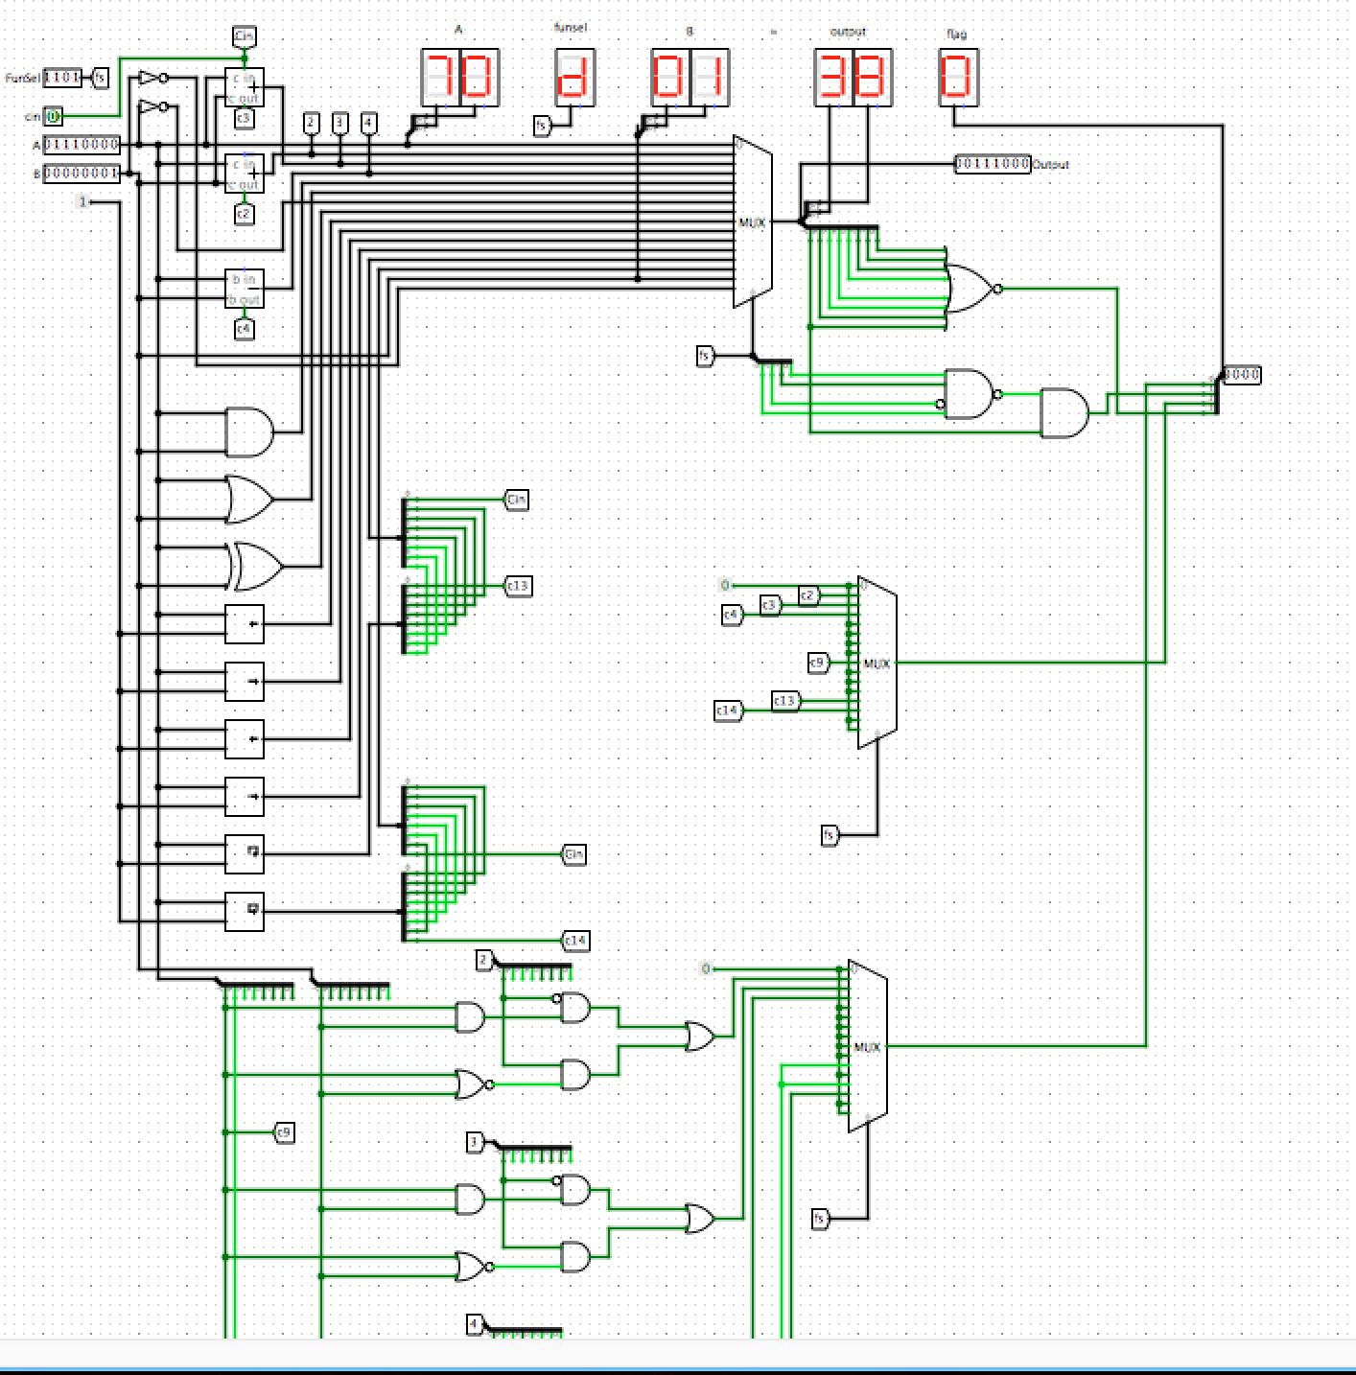**8 Bit - ALU**